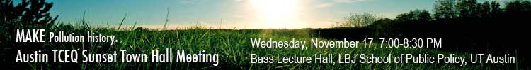

Central Texas, Make Pollution History!
TCEQ Sunset Town Hall Meeting
Wednesday, November 17, 7:00-8:30 PM
Bass Lecture Hall in Sid Richardson Hall
Room 2.104 at the LBJ School of Public Affairs, UT Austin
Free, ample parking, corner of Red River & 26th Street, and Capitol Metro bus routes.

Come tell your story about the TCEQ!

Panel followed by Open Mic.

Moderator,
- Eva Hernandez, Sierra Club
Panelists:
- Sarah Eckhart, Travis County Commissioner
- Robin Schneider, Texas Campaign for the Environment
- Dr. Elliott Trester of Austin Physicians for Social Responsibility
Central Texans want clean air and water.

We want polluters to be held accountable.

We want the Texas Commission on Environmental Quality (TCEQ) to do its job a lot better.

This is your once-in-a-decade opportunity to make changes at TCEQ through the Sunset Review process.

The Alliance for a Clean Texas and local groups are holding a series of almost a dozen Town Hall meetings across the state. Almost a thousand Texans have shown up in Houston, Victoria, Corpus Christi, El Paso, and Beaumont. Next are Dallas-Fort Worth, San Antonio, Austin, Lubbock, & Abilene!

Central Texans care deeply about our environment. Now is the time when we need you to step up to the mic and use your voice to make much-needed changes at TCEQ!

Sponsors: Alliance for a Clean Texas, Sierra Club, Texas Campaign for the Environment, Public Citizen, Austin Physicians for Social Responsibility, Texas League of Conservation Voters, Texas Impact, SEED Coalition, Central Texas Zero Waste Alliance

