For Immediate Release

Contact: Christy Muse, Executive Director, Hill Country Alliance, 512-560-3135 or christy@hillcountryalliance.org

HILL COUNTRY ALLIANCE ANNOUNCES CALENDAR PHOTOGRAPH CONTEST WINNERS AND 2011 CALENDAR RELEASE
Winning shots capture the beauty and cultural heritage of the Texas Hill Country while raising public awareness and offering daily inspiration for preserving its natural resources
Austin, TX – September 29, 2010 – The remains of an ancient cypress rise from an autumnal creek’s mist, trail riders gather for cowboy coffee on a fog shrouded morning, and cotton candy rows of a peach orchard in bloom foretell of summer sweetness. In the fourth annual contest held by the Hill Country Alliance (HCA) to photographically convey the beauty and uniqueness of the Texas Hill Country for the 2011 HCA Hill Country Calendar, the three winning photographs do just that. Along with ten other photographs chosen for the calendar, the three winning photographs offer a vivid portrayal of the region, and a daily reminder of a shared ideal and regional heritage worth sustaining for future generations. The Hill Country Calendar is now available for purchase from HCA’s website at HillCountryAlliance.org. Retailing for just $13.99, the calendar offers a beautiful and wallet-friendly way to celebrate the year and the region, and makes an ideal holiday gift.
The 550 entries received for the calendar contest were judged on originality, technical excellence, composition and ability to capture the essence of the Texas Hill Country. While the three winners each receive a cash prize, the personal stories behind their winning shots reveal a love of the region, and a desire to preserve it, as their true photographic motivation.
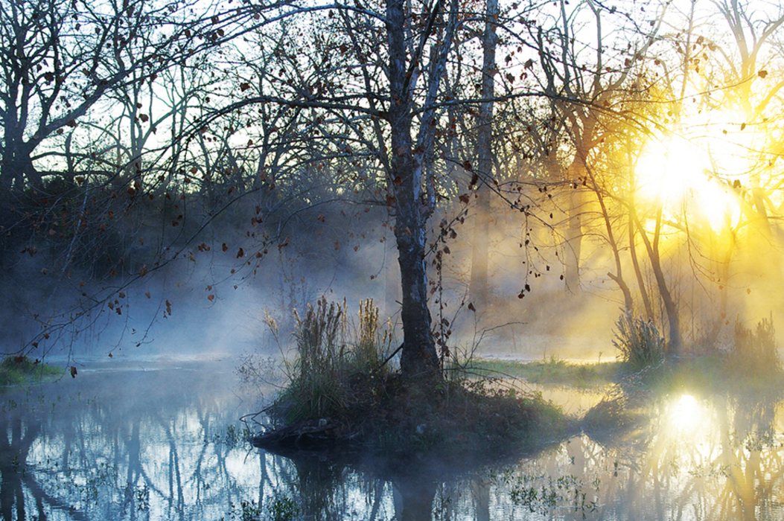
The natural authenticity of this year’s winners are exemplified by Charles McClure’s photograph Sunrise on Cypress Creek, an unretouched photograph shot in only one frame and winner in the “Natural Treasures” category. As McClure approached the low water crossing at Cypress Creek Bridge near Wimberley, a route he drives every day, an ethereal combination of sun, water and mist stopped him in his tracks; an experience he describes as “almost spiritual.”
“It is nice to win a prize, but the real honor was simply being witness to this amazing moment in time,” McClure reflects. “I lingered for a time to take it all in and thank my lucky stars I had a camera. This is the essence of the Texas Hill Country, a place where the water heals, the sky breathes, and the hills are sentient.”
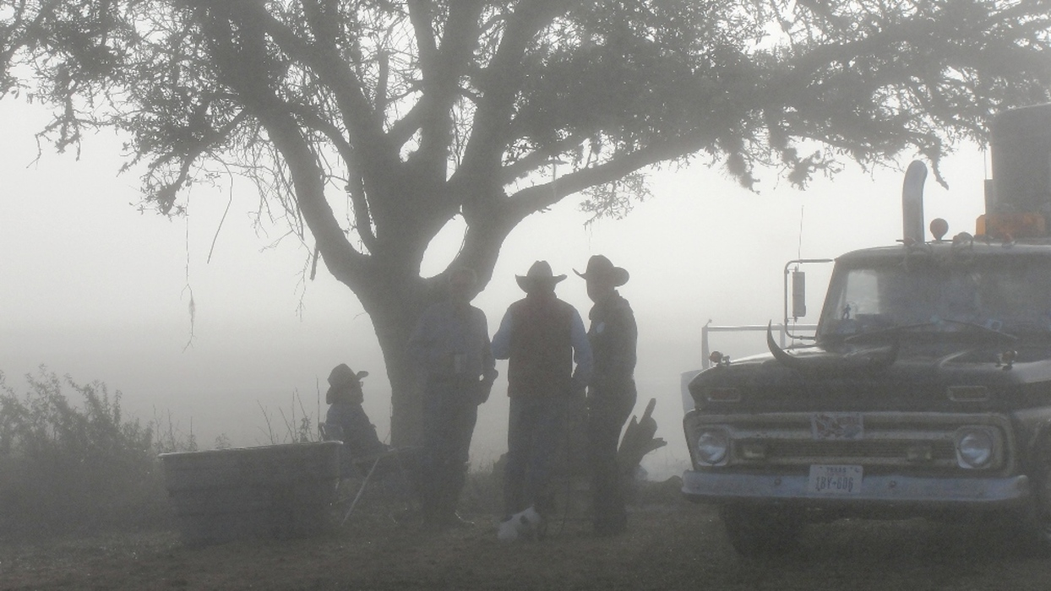
Mindee Poldrack, winner in the “Hill Country People” category, shares a similar experience in capturing Misty Morning while on the Original Texas Star Trail, an annual horse and wagon ride that traverses the route used by early settlers.
“On the trail this year, weather conditions extended the ride’s stay in Blanco at Yett Memorial Park,” recalls Poldrack, a photography buff who documents her adventures. “The shot wasn’t planned, but when I saw my father, brother, cousin, and a newfound friend silhouetted in the fog, gathered for early morning cowboy coffee, I knew I had to preserve this Texas Hill Country moment.”
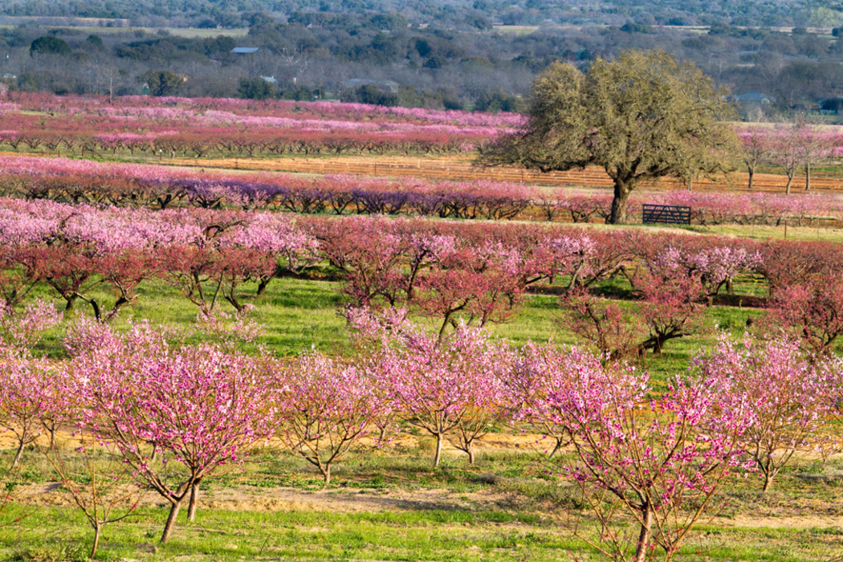
For Carolyn Whiteside, also a winner in last year’s contest, her research and determination to capture Hill Country orchards in bloom proved fruitful as her Valley of Peaches, taken at Vogel Orchard just outside of Stonewall, Texas, colorfully captured the category of “Our Unique Economy.” Whiteside, who grew up in rural Oklahoma but whose relatives were among the first settlers in this area, readily identifies with the local farming and ranching industry.
“We grew a garden and raised our own livestock,” Whiteside remembers of her youth. “For me, summer meant canning or freezing what we produced which sparked the thought of fruit orchards and their place in our unique Texas Hill Country economy.”
Whiteside, whose lifelong flirtation with photography, took a more professional turn upon her retirement from public school teaching, has won numerous awards due in no small part to her dedication to getting the shot.
“The day before I had taken several nice images from other orchards in the area but there was a considerable amount of smoke from some local burning,” recounts Whiteside. “The next day I decided it was just too beautiful to not go back and try again. As luck would have it, the air was now clear of smoke and, at the moment when the valley was blanketed by warm evening sunlight and the peach trees ablaze in pink, I took my shot.”
At a time when the area’s population is exploding, and ninety percent (90%) of the 17 county region is in unincorporated areas where unregulated development is the norm, the beauty and natural resources that make the Texas Hill Country so precious are at increased risk of irreversible damage. This possibility is one that the HCA is determined to avoid by raising public awareness of, and building community support around, the need to preserve the natural resources and heritage of the region by connecting people and place through efforts like the HCA Hill Country Calendar.
“The cultural heritage and natural beauty of our Texas Hill Country is why people came here in the first place, and it is up to us to preserve it,” says Rusty Ray, a photography enthusiast whose images have been featured in three previous editions of the HCA Hill Country Calendar, and who this year served as Calendar Committee Chair. “We all should be stewards of the land, and must do our best to conserve it for today and future generations.”

For more information or to purchase the 2011 HCA Hill Country Calendar, and to learn more about the HCA’s latest news, events, and initiatives, visit HillCountryAlliance.org.

