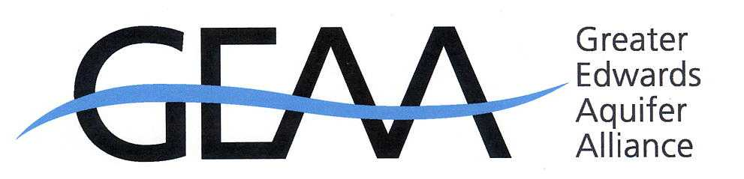
Contacts: Annalisa Peace 210-320-6294/275-9336
Ron Green 210- 316-9242
Request for Coverage

Angry Citizens To Be Heard at SAWS Board Meeting

When: Tuesday, April 3rd at 9:00 a.m.

Where: SAWS Headquarters, 2800 U.S. Hwy 281 North

What: Citizens of San Antonio and Bexar, and Medina and Bandera counties
protest SAWS plans to extend service into the Hill Country

On January 17, 2007, SAWS mailed notices of their intention to amend their Certificate of Convenience and Necessity (CCN) to allow them to provide sewer utility service to parts of Bexar, Medina, and Kendall Counties that currently do not have sewer service.

The area proposed by SAWS is made up of the recharge and contributing zones of the Edwards Aquifer. The cheapest and most direct way to construct a sewer system in this area is to install the sewer lines in creek and stream beds. In that way, the utility could rely on gravity drainage and not install expensive pumping stations.

Installing this sewer system would impact northwest Bexar County and beyond in several ways. Construction of sewer lines in stream beds would devastate the country side. Hill Country creeks and streams would never recover from the destruction. Providing sewer service would open up northwest Bexar County and beyond to literally 10s of thousands of houses. This area would look exactly like Stone Oak and other areas where unbridled development was allowed with no regard for the environment, the health of the Edwards Aquifer, and the quality of life. High-density development in this area would further jam a thoroughfare system that TXDoT claims has no money for improvement or expansion for the next several decades.

Currently, development of this area is limited by the absence of utilities. Development is contingent on the availability of services, namely water, electricity, thoroughfare roads, and, very importantly, sewers. If a sewer system is not available, the density of development is limited because each lot would require a septic system. However, if developers are successful in convincing public utilities, such as SAWS, to install a sewer system at the public's expense, then high density development would be possible and private developers would not bear the burden (and cost) of providing this very important utility. The decision by the Texas Commission on Environmental Quality on whether to approval this requested amendment will have a profound impact on northwest Bexar County and beyond.

Affected groups and individuals have requested a public hearing to contest SAWS plans to open this area to high-density development by providing sewer service, and will contest permitting by the TCEQ.

Greater Edwards Aquifer Alliance (GEAA), a coalition of thirty-six organizations from Austin to Del Rio, all dedicated to maintaining the health of the aquatic ecosystem of Central Texas and the rivers and streams flowing across it through the Edwards Aquifer and toward the Gulf of Mexico.
XXX

