FOR IMMEDIATE RELEASE
PRESS RELEASE
Contact
Christy Muse, Executive Director – Hill Country Alliance (christy@hillcountryalliance.org)
www.HillCountryAlliance.org
512.560.3135
Lightning strikes twice in Hill Country contest
Hill Country Calendar raises awareness and resources for Hill Country planning
Austin (November 10, 2008) – As one of the fastest growing areas in the nation, the Hill Country faces many unique problems. Each year, the Hill Country Alliance, a nonprofit organization in Central Texas, holds a contest to find the best pictures taken of the Hill Country.

“We were thrilled with the sheer volume and quality of the photos this year,” said Lee Carrell, a founding board member of the alliance and chairman of the Photo Contest Committee.

The alliance chose the best 12 pictures from a pool of more than 400 entrants to appear in their annual calendar and represent the alliance’s mission of regional planning, preservation and conservation. The top three winners of these 12 earned prizes of $500, $300 and $200, respectively.

The Calendar is available now at select area retailers or online at www.HillCountryAlliance.org. All proceeds to towards the mission of the Hill Country Alliance. Signed and framed prints of the winning photos will be on display at Westcave Preserve (www.westcave.org) throughout the month of December.

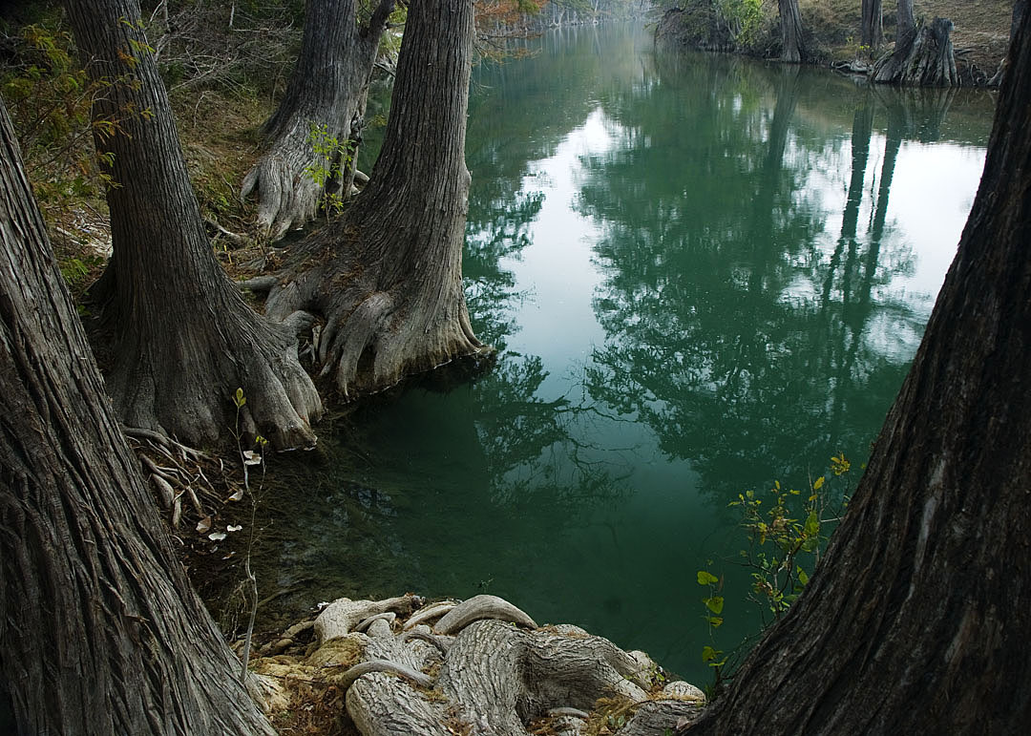
“We hope this calendar will serve as an educational tool for everyone in our region,” said Christy Muse, executive director of the alliance. “It will take active citizens working with landowners and elected officials to protect the amazing natural assets of the Hill Country.”

This year’s first-place winner, Herb Smith, also took home the top prize in last year’s contest.

“I was very excited and surprised,” Smith said. “I never dreamed that lightning would strike twice like this.”

Smith took the winning picture, “Emerald Waters of the Blanco” (pictured, left) on the Blanco River upstream from Wimberley. “It’s a spot near our home, a place I’ve enjoyed a lot,” he said. “I walk along the river pretty much every day.”

Smith grew up loving both nature and photography – he had a darkroom when he was 12. Though he has taken many pictures, Smith remembers that his winning photograph was taken on a crisp November morning at about 8:30 a.m.

“Entering the contest combined my love and enjoyment of photography with the goals of the alliance,” he said.

Winning second place in the contest is Jared Holmes, originally from Pennsylvania, near the Pocono Mountains. He came to Texas to attend Texas A&M University for a degree in zoology and has been doing nature photography since he graduated in 2005.

“The Hill Country is in the middle of everything,” Holmes said. “There are a few beautiful state parks, a lot of ranches, and plenty to photograph.”

Holmes took the winning “Road Runner or Tree Runner” on Rocky Road in Blanco County. He says he was lucky to capture this roadrunner on film. “I chased it up the road and it hopped the fence and then it turned back at me,” he said. “When people think of the hill country, they think of hills, roadrunners and rattle snakes.”

The third place winner, Rusty Ray lives in Austin, where he was also born and raised. Ray took “Evening Glow in Llano County” at a small stream on the Freeman Ranch. He has taken pictures for a hobby and for business for the last 10 to 15 years, throughout his career as a wildlife biologist. “You can capture images a lot of people don’t get to see,” Ray said. “You can show them the outdoors.”

Ray has been around the Hill Country his whole life, getting his undergraduate degree at Southwest Texas University and completing his graduate work in Central Texas. He currently works for the Lower Colorado River Authority. “It’s a pretty fine place to live,” Ray said. “Texas is beautiful for me, from east to west.”

Along with Ray’s photograph, each of the winning entries was chosen by a team of judges out of an original pool of more than 400 photographs. Making up the team are three members of the art and photography world: Damian Priour, Dana Friis-Hansen and Stephen Clark.

Priour is not only a founding member of the Hill Country Alliance, but also a well-known sculptor and the official Sculptor of Texas for 2008, appointed by the Texas Legislature. In addition to being immediate past president of the alliance, Priour serves on the boards of the Austin Museum of Art and the Umlauf Sculpture Garden.

Dana Friis-Hansen is the executive director and curator of the Austin Museum of Art, with a special interest in photography. Stephen Clark is the owner of Stephen L. Clark Gallery, a high-end photograph gallery in Austin. Both are very respected professionals in their fields.

“Their objective was to evaluate the entries technically, artistically and most of all, their ability to capture the essence of the Hill Country,” Muse said.
Check the Hill Country Alliance Web site for information on the 2009 Hill Country Calendar and for updates on Hill Country news and events.

