Transforming the Strip:
Towards a Smarter, More Sustainable Future for Gateway Approaches

Re-development Design Strategies to Create Mixed-Use Centers

This presentation focuses on practical ways of reclaiming existing highway strips characterized by dysfunctionality and visual blight. Multiple strategies blending the twin disciplines of Conservation Design and New Urbanism are discussed for rebuilding these corridors, gradually increasing their functionality and attractiveness.
These concepts offer significant opportunities for commercial and mixed-use redevelopment, particularly in areas with existing infrastructure, increasing the viability of businesses, service providers, and current /future public transit lines.

A digital slideshow illustrates progressive approaches, emphasizing multi-story mixed-use buildings, affordable housing, public transit possibilities, shade tree planting, design standards, signage, native landscaping, improved circulation patterns, parking lot orientation, stormwater infiltration/recharge, night sky protection, and solar features.
This topic is of interest to civic leaders, Planning Board/Commission members, professional planners, landscape architects, and engineers, commercial property owners and investors, and developers, who stand to benefit from the redevelopment and adaptive reuse of aging highway commercial corridors into multi-use centers for the 21st century.
,
Because the typical design life of most of these buildings is often only 25 to 30 years, communities can position themselves to guide the future replacement of existing structures when they are redeveloped and demolished, by working now to articulate a vision, adopt plans, enact flexible codes, and provide other incentives to help assure the future will produce economically viable and aesthetically attractive corridors that will meet the multiple needs, desires and challenges of local residents and business owners.
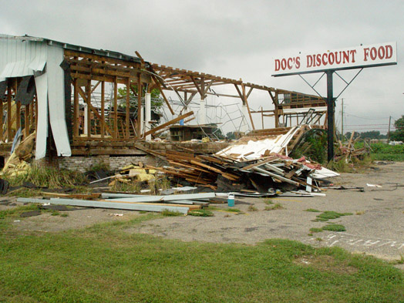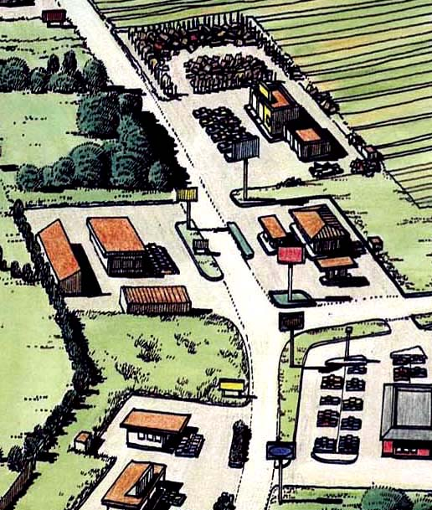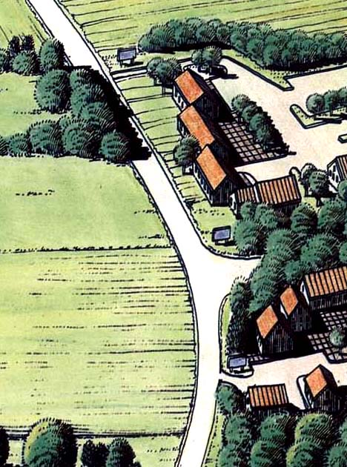

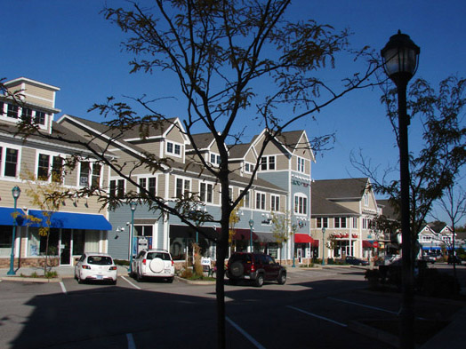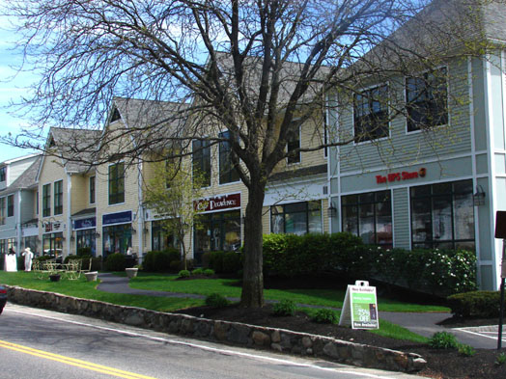

"Attractive, well-designed, and landscaped highway corridors are always more profitable than corridors cluttered with giant signs and haphazard development. Both the public and private sectors are recognizing that investing in high-quality design is good for both business and the community."
--- Ed McMahon, ULI Senior Fellow, Urban Land Institute, Washington, DC
The workshop addresses the following specific topic areas, among others:

- Planting shade trees extensively along the highway, internal streets and pedestrian ways, and within internal parking areas, to increase attractiveness, user-friendliness, visitation frequency, and economic viability, in addition to cleansing the air and soothing the nerves

- Calming traffic through landscaped medians and roundabouts

- Integrating with existing or future mass transit: bus routes and light rail lines, along these corridors whose length and linearity are a perfect match for these services,

- Ensuring the provision of safe pedestrian walkways through parking lots and alongside internal streets

- Providing opportunities for affordable housing, above shops and offices, as was commonly done in downtowns before WWII, taking advantage of the same foundation and roof system already being provided).

- Designing around natural features (streams, trees, etc) and around historic/cultural features (farmhouses, barns, stone walls, etc.),

- Managing stormwater to emphasize groundwater infiltration and recharge, through rain gardens and planting areas situated several inches below grade,

- Using native species in landscaping, e.g., for shrubs and wildflowers,

- Setting maximum building setbacks from the highway,

- Internal parking behind the buildings and/or within the development area,

- Creating internal streets, and linkage to adjoining properties to facilitate inter-parcel circulation for vehicles,

- Establishing minimum height standards, (such as two stories in functional height) to encourage vertical integration of compatible mixed uses, such as retail and office, or rental residential.

- Setting standards for signage , emphasizing the smaller-scale "monument" style signs (rather than tall pole-mounted designs),

- Requiring outdoor lighting to have vertical "cut-offs'" to keep light rays directed downward, not outward or upward (preventing roadside glare, light trespass onto adjoining properties, or violation of dark-sky principles).

This workshop presentation is generously illustrated with numerous successful examples, including photos of national chains and franchises which have been required to either restore existing historic buildings or to design and construct new buildings fitting the local character, rather than erecting their standard boxes. It also includes examples of infilling techniques for downtown situations.
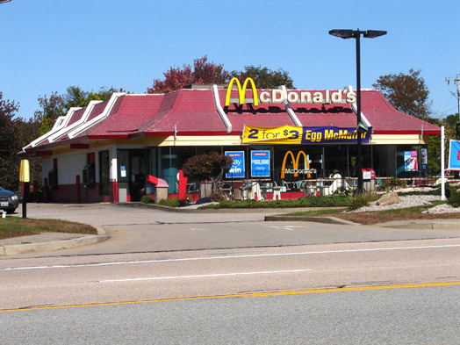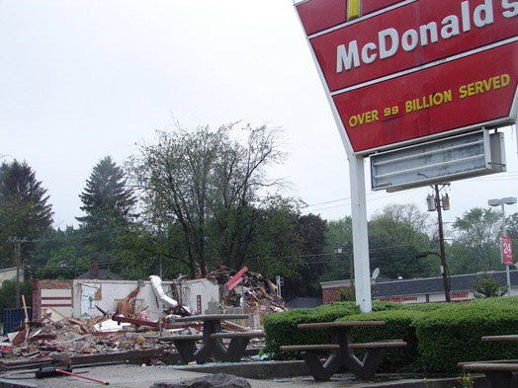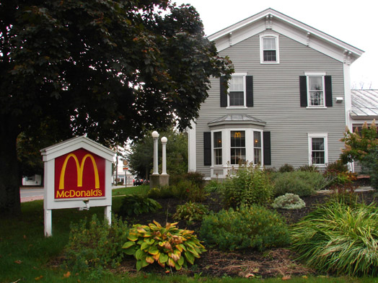

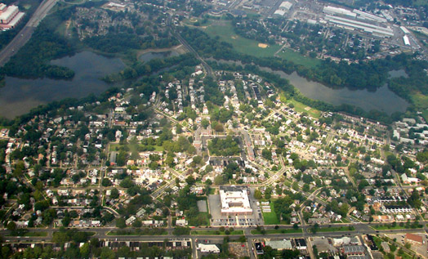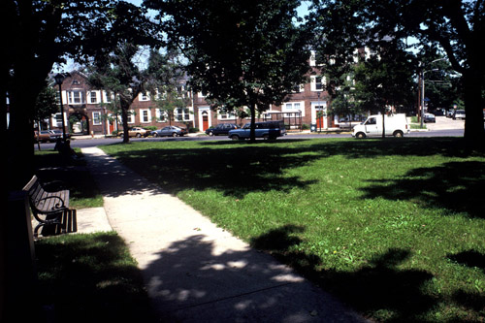
Yorkship Village and Town Center detail, Camden NJ, 1917: Located adjacent to Mass Transit

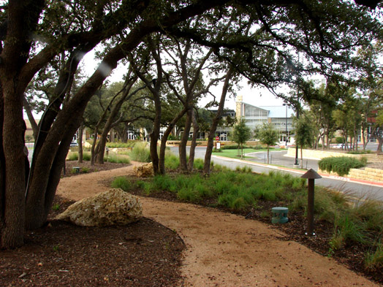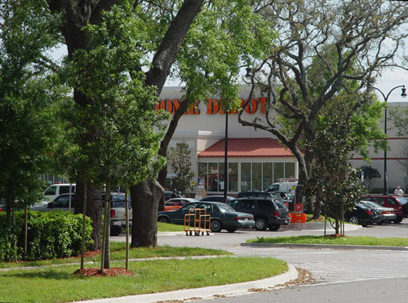
Designing around Mature Trees: Georgetown TX and Lake County FL

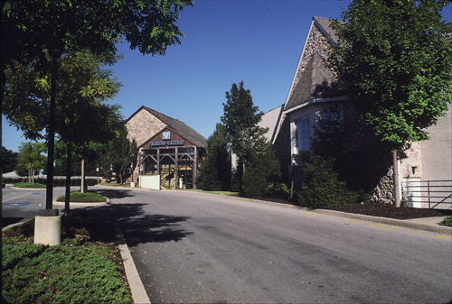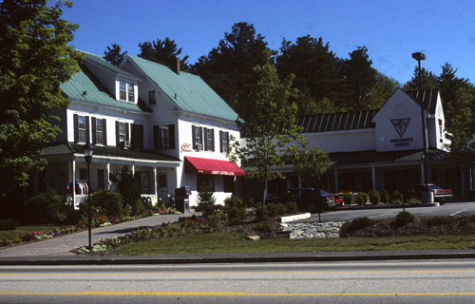
Designing around Historic Farmhouses and Stone Barns: Conway NH & East Pikeland, PA

Contact Information: Randall Arendt, rgarendt@cox.net, and 401-792-8200

